In the GWSAPI, there 6 functions (the type must be included in all the time otherwise it wont display any data)

1. getAllWines

this function will return all the wine’s data(in JSON format) to you, here is the example of data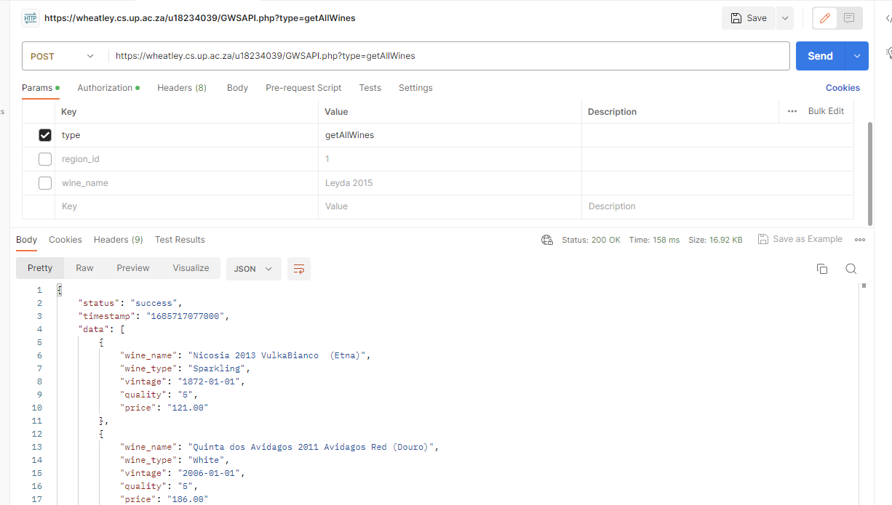

1. SortWinesByPrice

This function will return the wines by price in ascending order

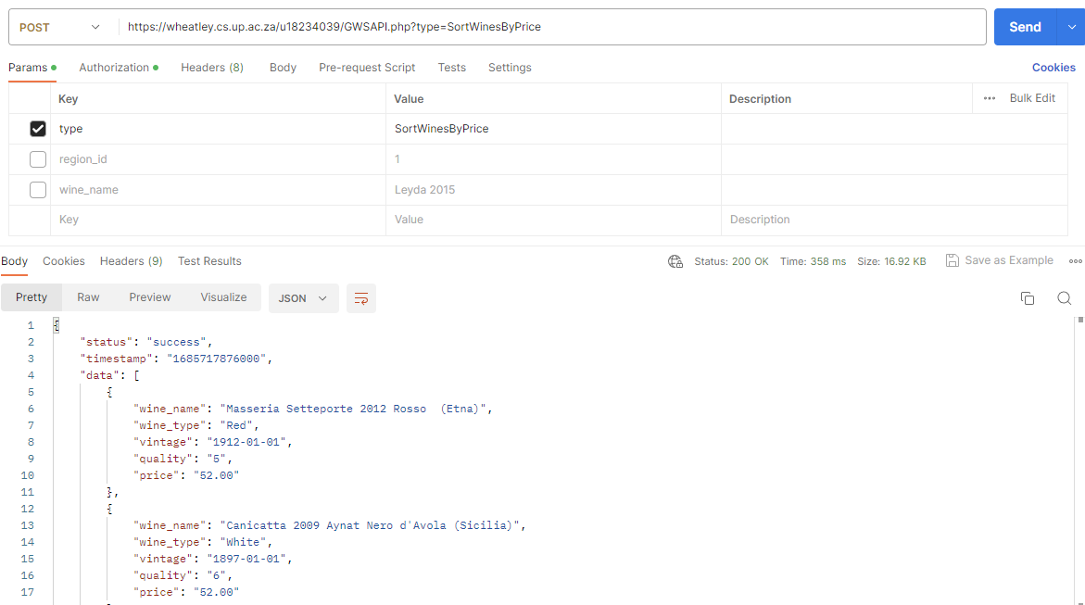

1. SortWinesByQuality

This function will return the wines by quality in ascending order

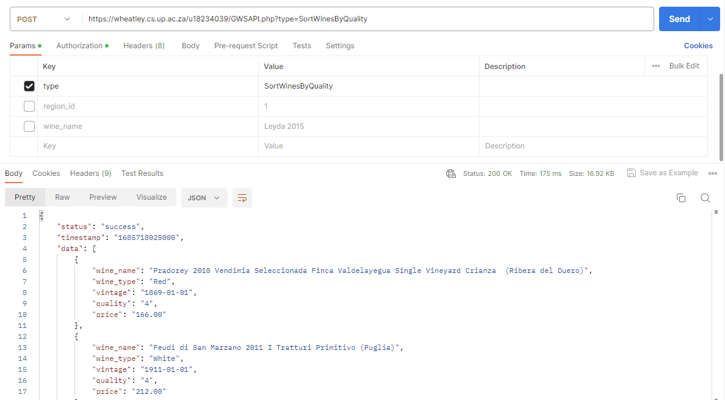

1. SortWinesByRegion

This function will return the wines by region_id, you need to add a region_id parameter

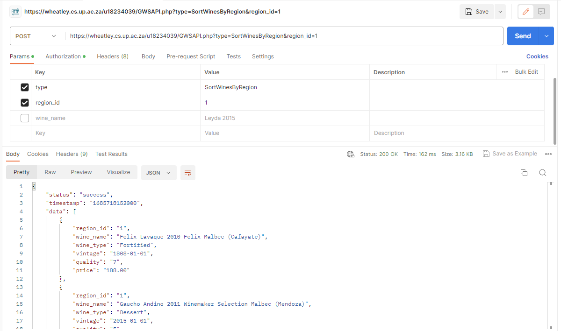

1. SortWinesByName

This function will return the wines by wine_name, you need to add a wine_name parameter (this function enabled fuzzy search)

If you want to get this result 

You can do simply like this

1. getWinesByWinery

This function will return the wines by selected winery_id, you need to add winery_id as parametre

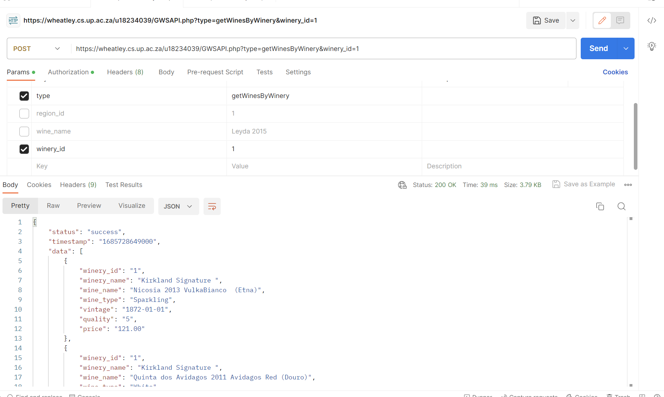

how do you use the API in javascript,

here is the example (frontend can reference it based on the situation)

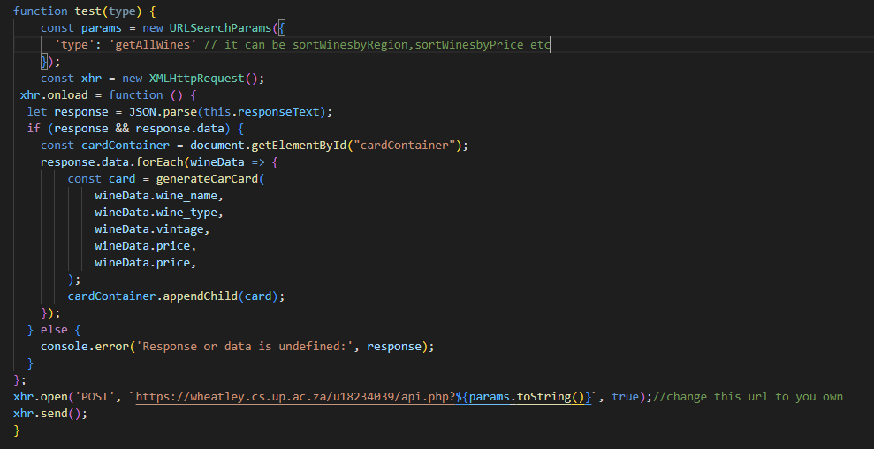

If you call the api outside of Wheatley(run the php locally or other cloud platform), you should add something like this

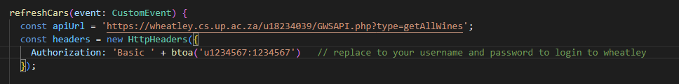

## How do you set this API in your environment

1. Download sql files( uploaded in the Whatsapp group chat)
2. Import it to your Wheatley phpMyAdmin, give the database any name you like
3. Change the GWSAPI.php configuration to you own configs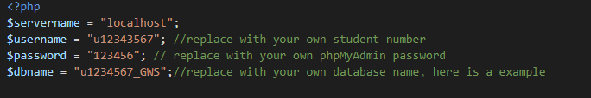
4. Then you can test it on Postman to check if it is work